**Discrete-time Signals Processing**

**Assignment No.01**

**Assignment Date: __14-10-2023______**

**Firm Deadline till __23-10-2023______ (During Class ____)**

**OBJECTIVE:**

The objective of studying exponential sequences lies in their pivotal role in signal analysis and processing. Real exponential sequences are fundamental in modeling signal dynamics, while complex exponentials are essential for frequency domain analysis. This knowledge is used for effective modeling and analysis of signal behavior.

**TASK:**

**Write MATLAB code to generate output graphs for exponential sequences for Real and Complex parameters.**

* **Using Equations x[n] = A α^n for Real Graphs. Let A=1.5, n= -10 to 10**

1. **for (-1 < alpha < 0), try alpha= -0.5**
2. **for (0 < alpha < 1), try alpha=0.7**
3. **for (|alpha| > 1), try alpha= 1.1**

* **Using Equations x[n]=|A |e j(ω0n+φ) = |A | cos (ω0n + φ) + j |A |sin (ω0n + φ) for Complex Graphs.**

**Let A=2, n= -10 to 10**

1. **for (-1 < alpha < 0), try alpha= -0.5**
2. **for (0 < alpha < 1), try alpha=0.7**
3. **for (|alpha| > 1), try alpha= 1.1**

**Comment on each output graph**

**Hints:**

**EXPECTED GRAPHS FOR REAL Exponential:**

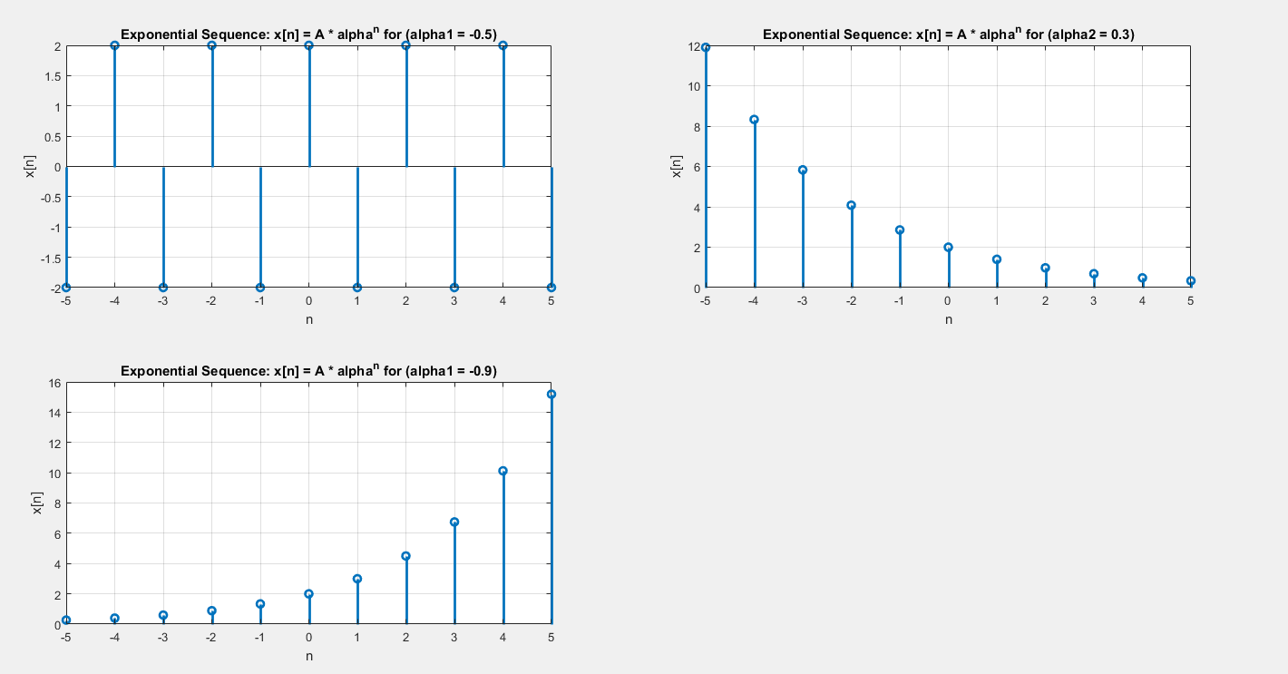

**EXPECTED GRAPHS FOR COMPLEX Exponentials:**

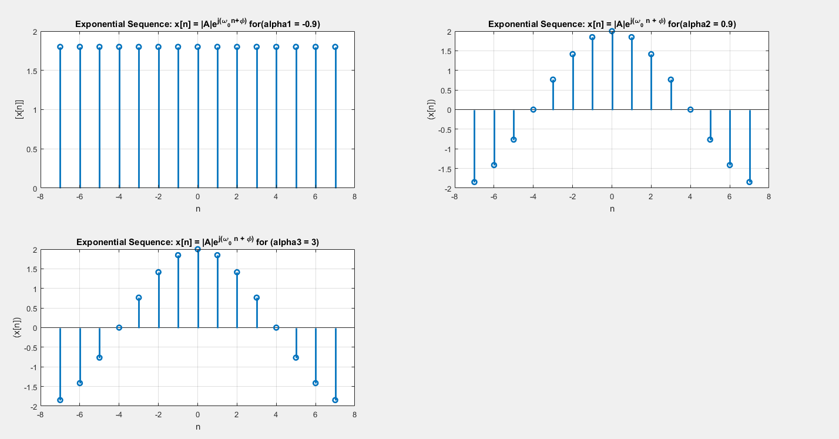

**NOTE:**

* **For Complex Equation Graphs Use These Values for Plotting**

** **

* **Read pages 17 to 19 from (Discrete-Time Signal Processing) Alan V. Oppenheim Ronald W. Schafer 3rd Edition for better understanding.**